LAB Logbook
Lab 1
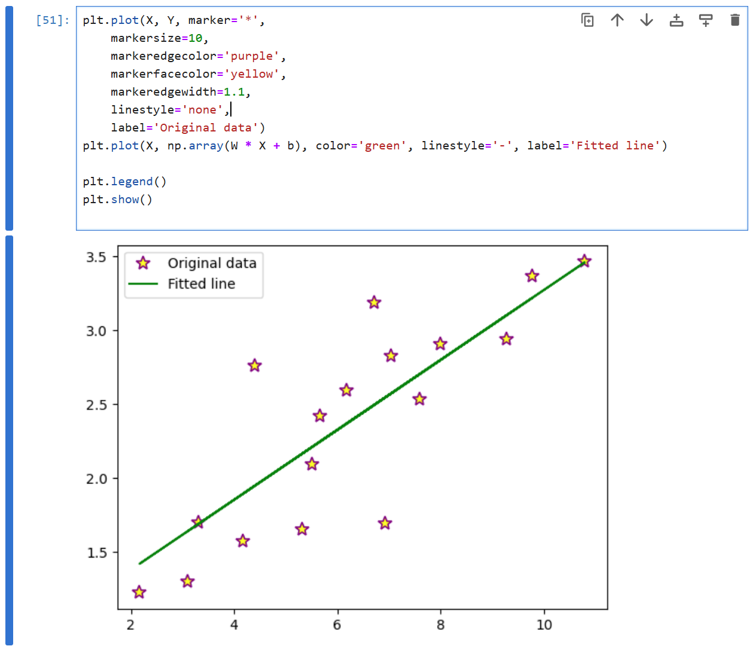
Lab 2
1.
Training Accuracy: 0.97
Test Accuracy: 0.94
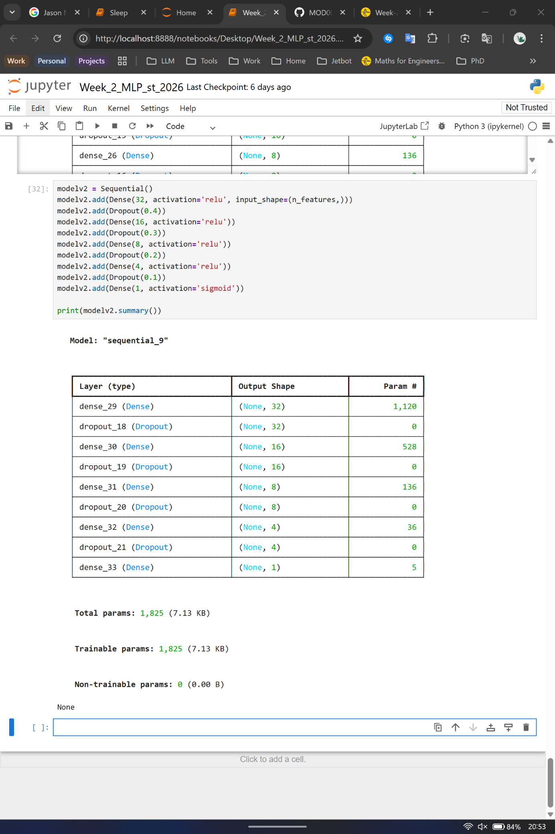
2.
3.
O1: 1.808
O2: 1.808
Lab 3
Training Accuracy: 0.99
Test Accuracy: 0.89
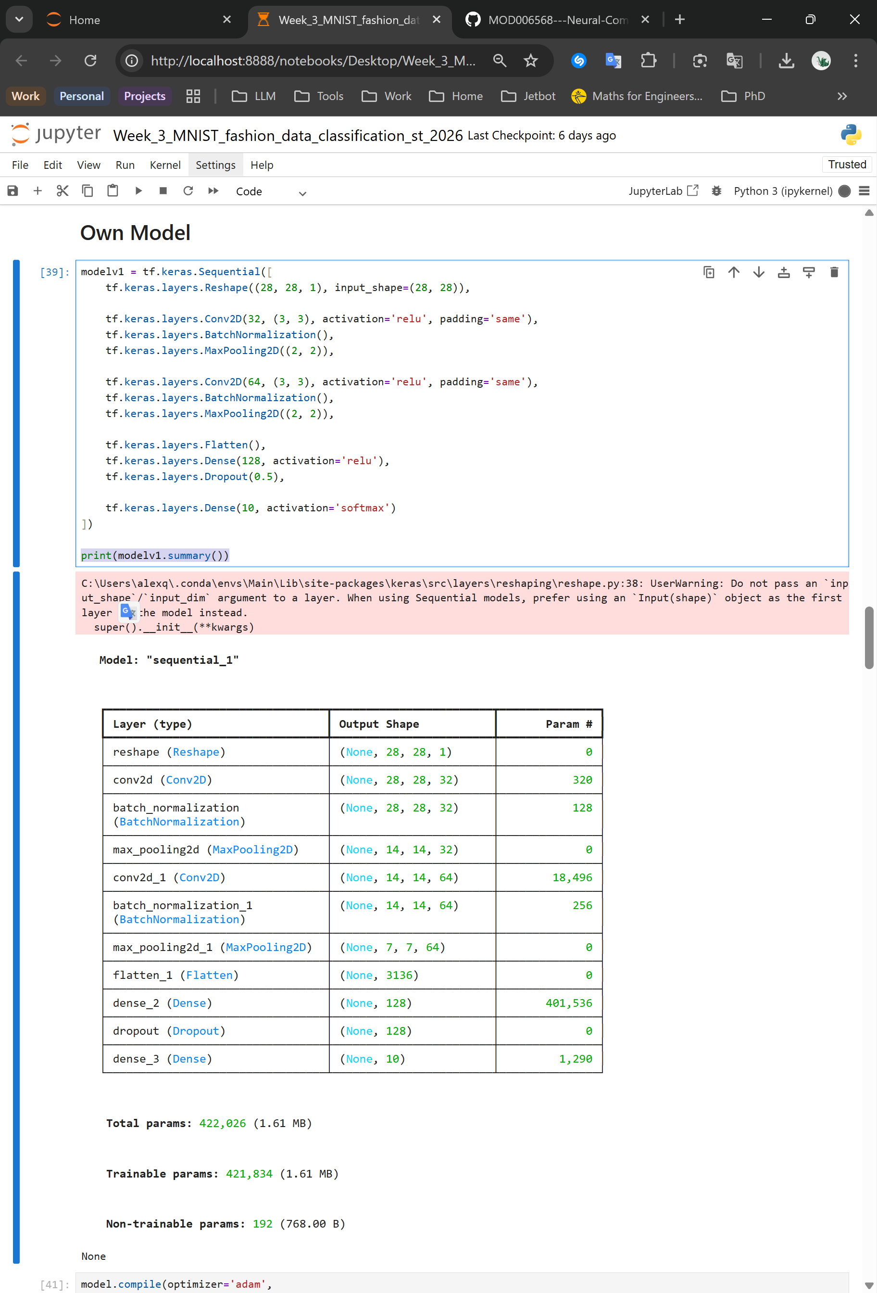
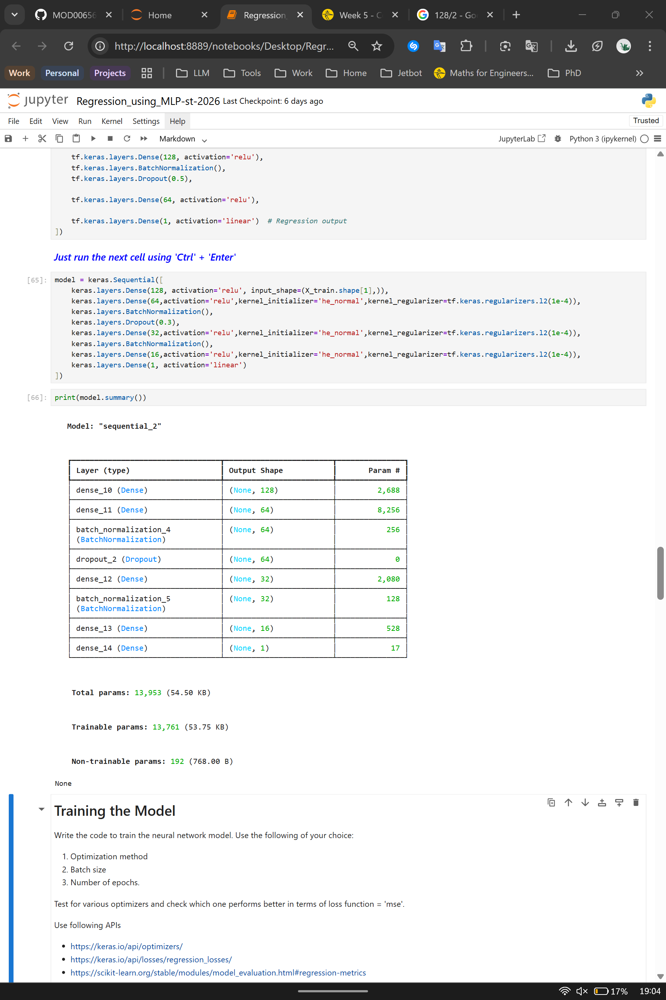
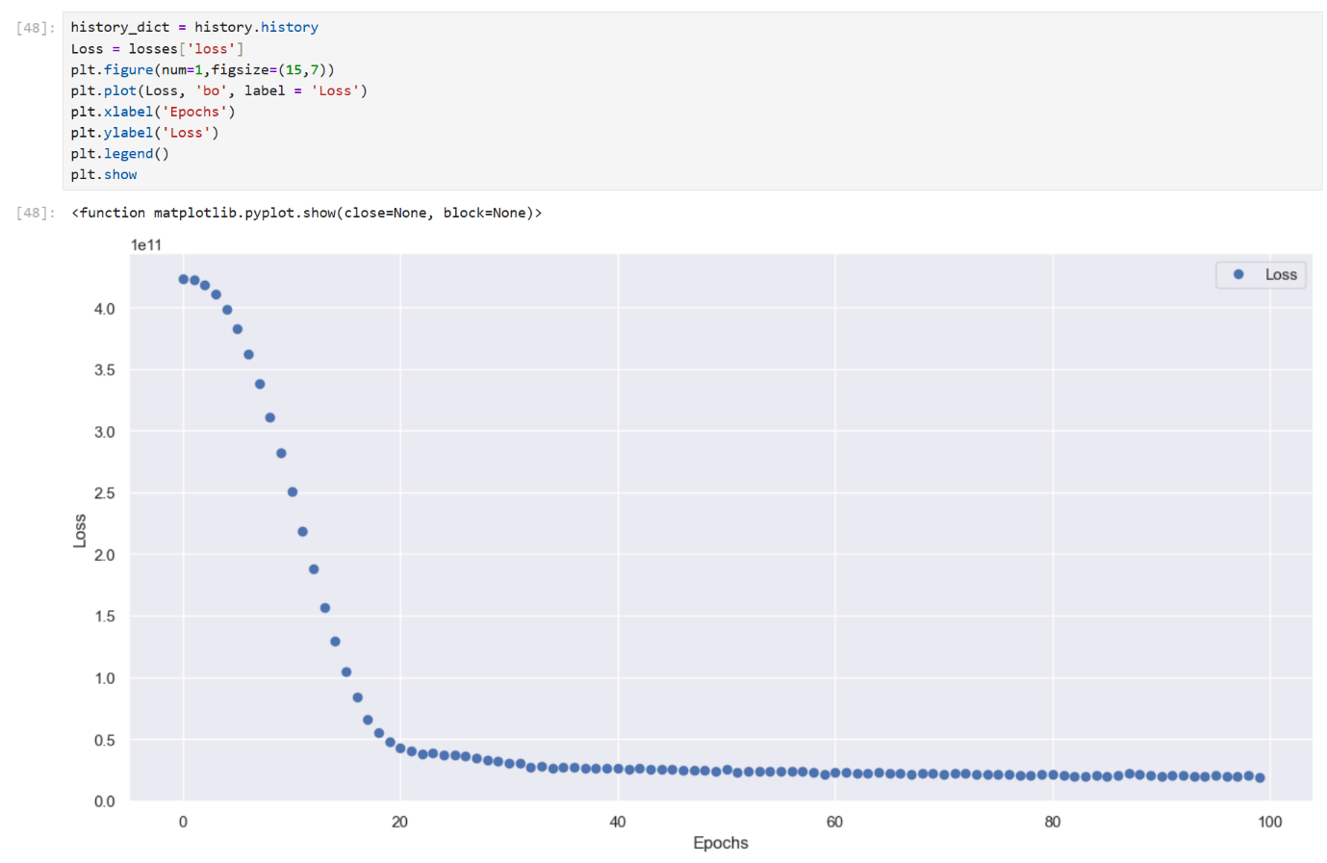
Lab 4
Lab 5
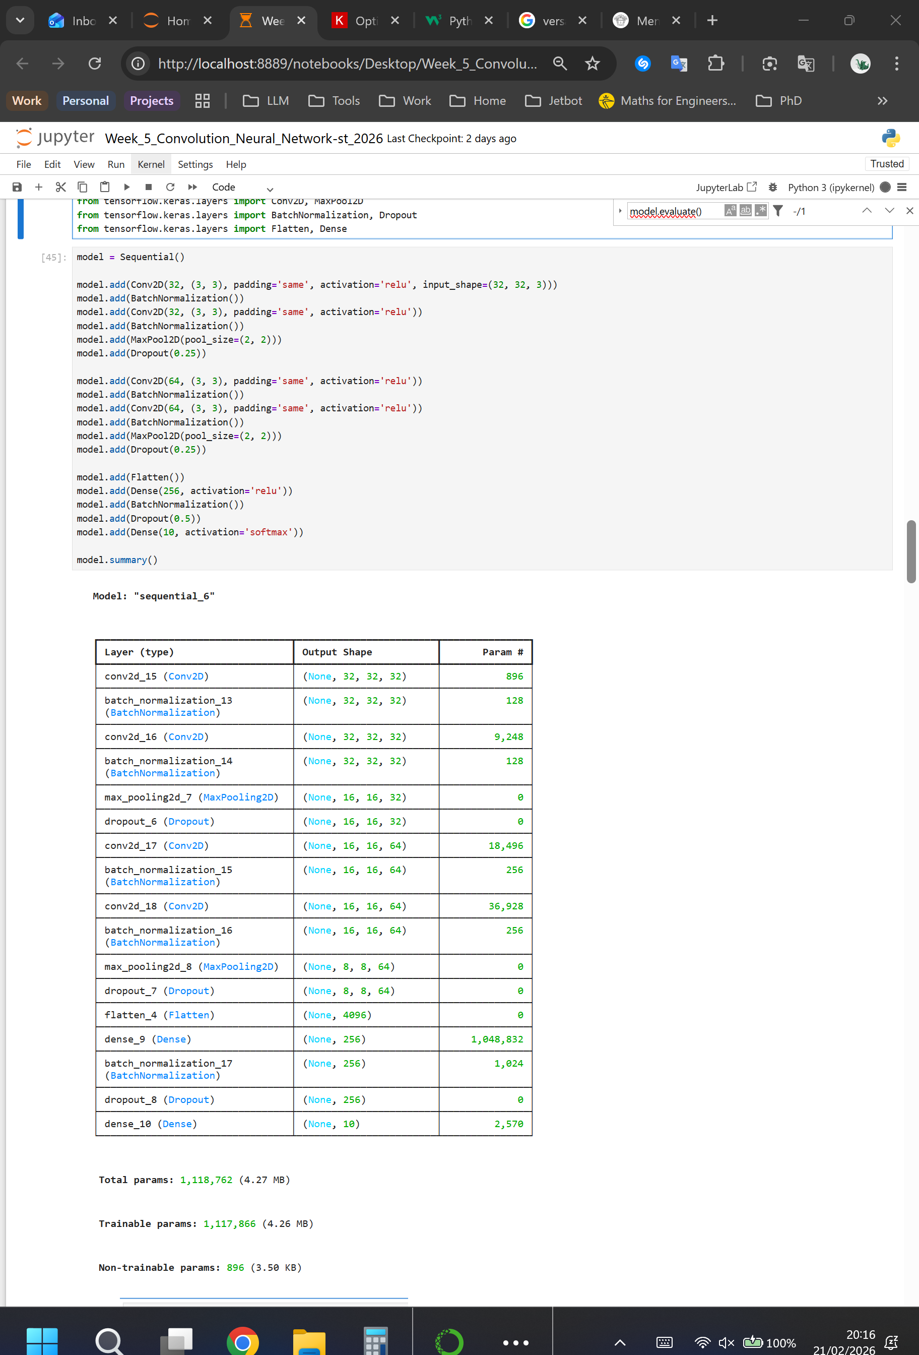
1.

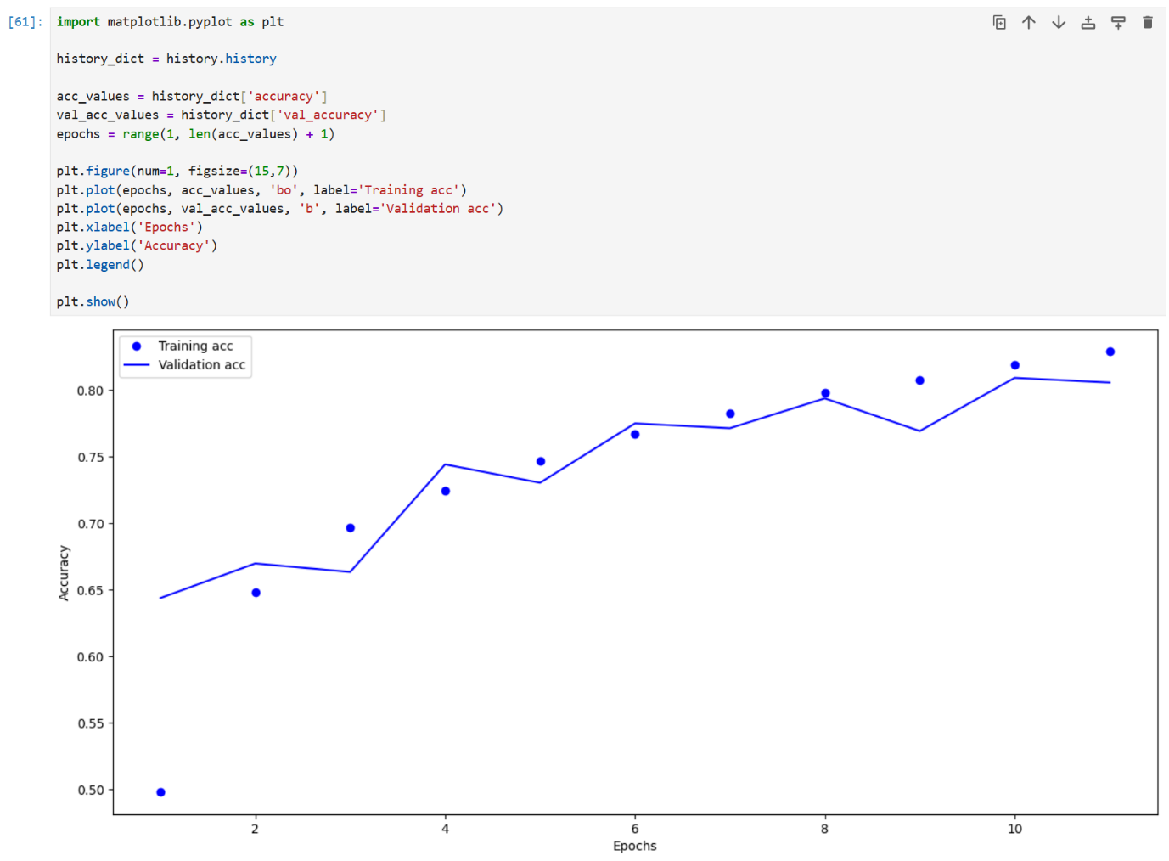
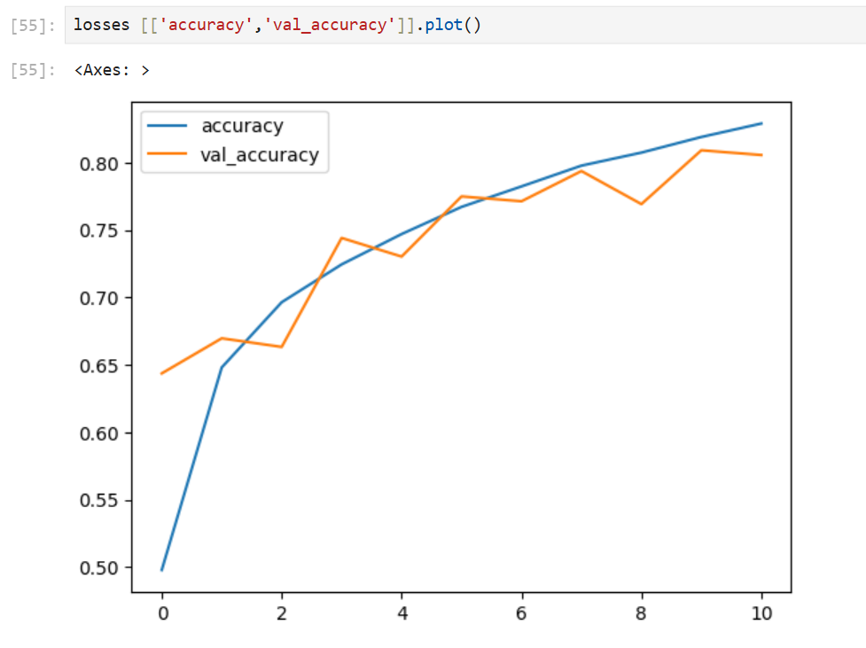
2.

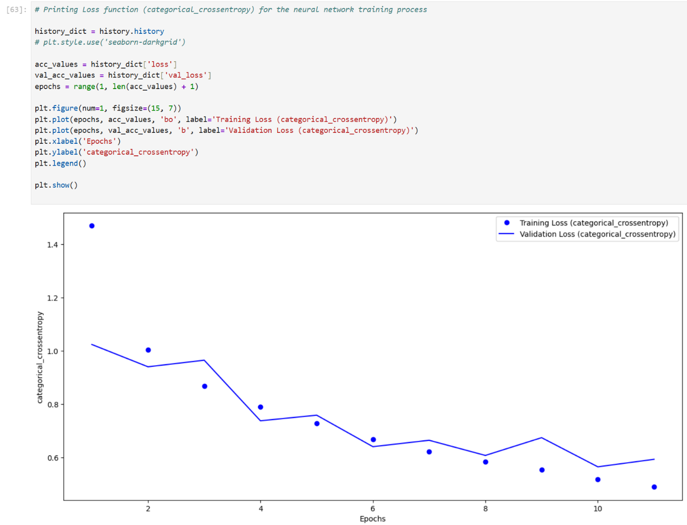
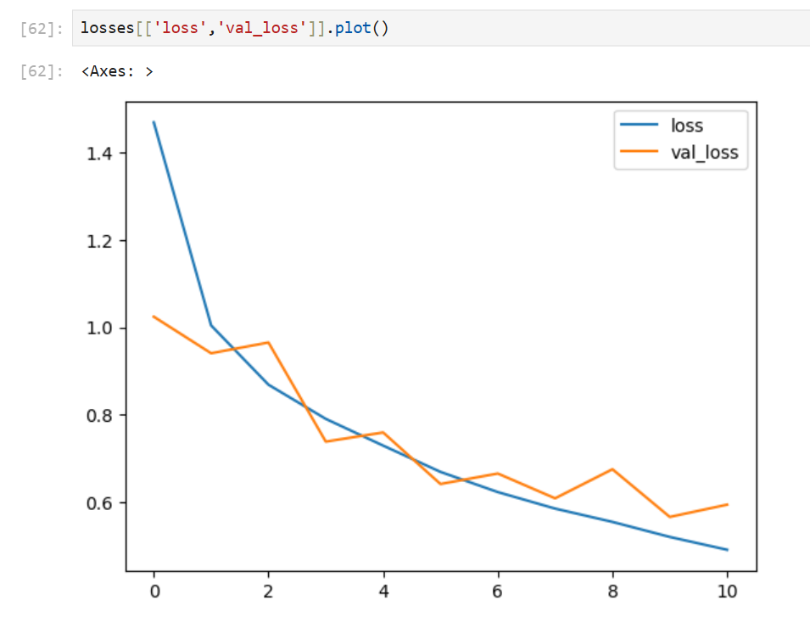

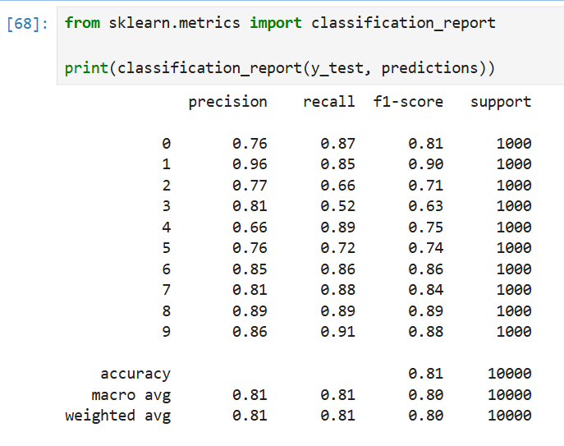
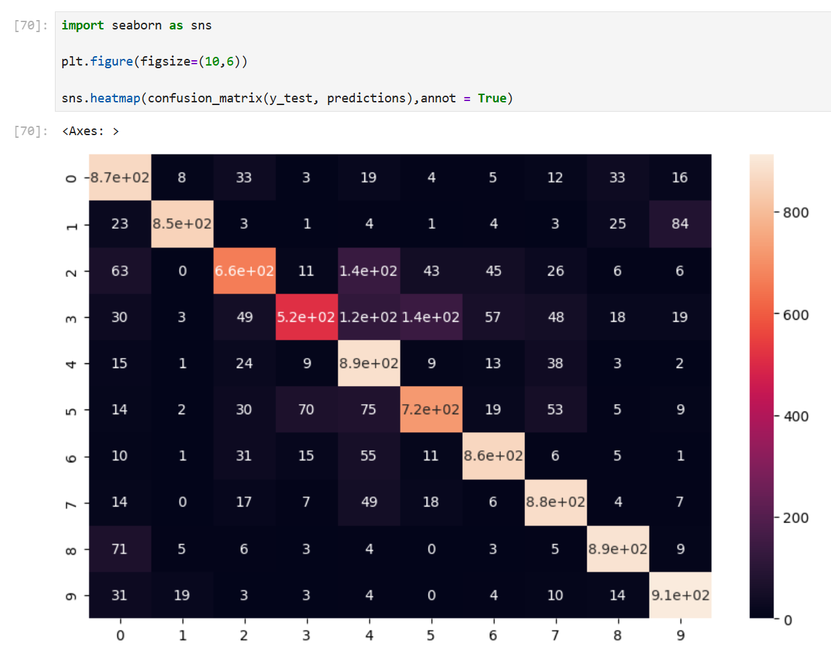

3.
The four graphs above indicate that no overfitting has occurred yet. During a few epochs, there were notable spikes in Validation Loss and notable drops in Validation Accuracy. These always balance themselves out in the following epoch. To detect overfitting, more epochs would have been needed to obtain unambiguous results.
4. (Optional Task)
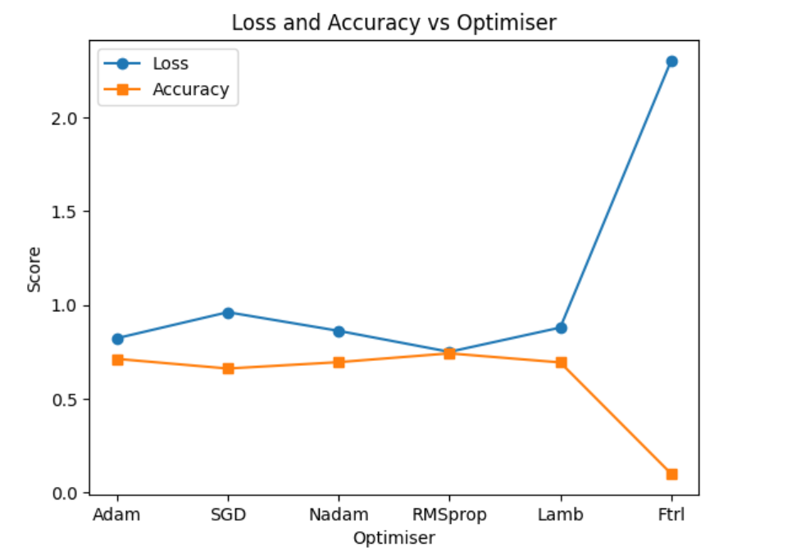
Loss and Accuracy of different Optimiser after three epochs:

Lab 6

Lab 7

Lab 8

Lab 9

Lab 10

Lab 11

Lab 12

